**Document Name:** Sprint 2 Plan

**Product Name:** MuscleMinder

**Team Name:** FitTech Innovators

**Release Name:** MuscleMinder Launch

**Sprint Completion Date**: 5/8/2024

**Revision Number:** 2

**Revision Date:** 04/30/24

Sprint 2 Plan

### Sprint Goal

The goal of this sprint is to implement workouts and workout plans based on the different muscles.

## Sprint 2 User Stories

* High Priority User Story 2.1 [13 Points]: As a user, I want to input my workout plan so I can validate if it hits all muscle groups efficiently.
  + Task 2.1.1: Research and compile a dataset of various workouts Workout name, muscle groups, intensity/difficulty (3 hour)
  + Task 2.1.2: Find a host and setup SQLite database (1.5 hours)
  + Task 2.1.3: Create schema that contains all necessary tables and attributes (2 hour)
  + Task 2.1.4: Load dataset and add constraints (3 hours)
  + Task 2.1.5: Add an Express JS Skeleton (3 hours)
  + Task 2.1.6: Connect backend to database (5 hours)
  + Task 2.1.7: Enable frontend to query the backend (4 hours)
  + Task 2.1.8: Add functionality to the backend to send information to the frontend (10 hours)
  + Task 2.1.9: Add functionality to send the muscle specific information to the frontend (8 hours)
  + Task 2.1.10: Add functionality to setup extracting that muscle specific information from the database. (5 hours)
  + Task 2.1.11: Enable fronted to take input from a dropdown menu of exercises (8 hours)

**Task assignment:**

| Qays | Riksean | Safwan | Alexander | Jack |
| --- | --- | --- | --- | --- |
| Task 2.1.1  Task 2. | Task 2.1.7 | 2.1.2  2.1.3  2.1.4  2.1.6 | Task 2.1.11 | 2.1.5  2.1.8 |

**Initial Burn-up Chart**

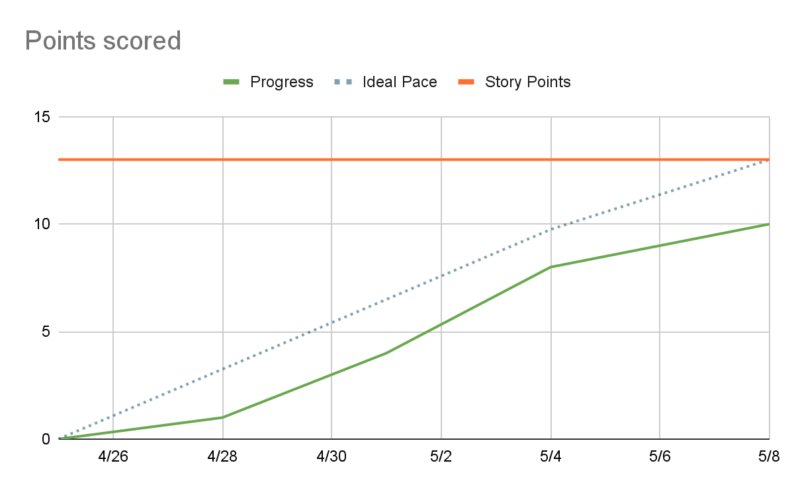

| **Titled User Stories,** | **Tasks Not Started,** | **Tasks In Progress,** | **Tasks Finished** |
| --- | --- | --- | --- |
| User Story **2.1** [13 Points]: Workout plan validation. | 2.1.7  2.1.8  2.1.9 | 2.1.6  2.1.10 | 2.1.1 2.1.2  2.1.3  2.1.4 2.1.5  2.1.11 |

**Scrum Times:**

**Monday: 1:30 pm - 2:15pm**

**Tuesday: 1:30pm - 2pm**

**Wednesday: 1:30pm - 2:30pm (TA Meeting)**

**Thursday: 1:00pm - 2pm**